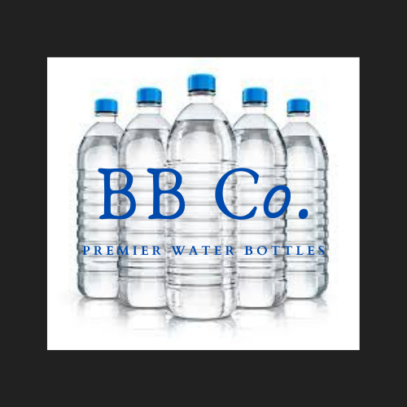

ERP Simulation Analytics: Presented by Company BB

Moderated by Professor Ming Wang

Table of Contents

**Introduction** **2**

**Business Process Model and Notation** **3**

Figure 1 - Business Process Diagram 3

**Evolving Business Strategy** **4**

**Sales Data Multidimensional Modeling** **4**

Figure 2 - Sales Data Star Schema 4

**Purchase Order Multidimensional Modeling** **5**

Figure 3 - Purchase Order Star Schema 5

**Marketing Multidimensional Modeling** **6**

Figure 4 - Marketing Star Schema 6

**Sales Revenue** **7**

Figure 5 - Sales Revenue by Company AA, BB, CC in Fiscal Year(2 Quarters) 7

Figure 6 - Sales Revenue by Product in Fiscal Year (2 Quarters) 7

Figure 7 - Sales Revenue Trends for Company AA, BB, CC in Fiscal Year (2 Quarters) 8

**Market Analysis** **8**

Figure 8 - Market Share of Products by Company AA, BB, CC in Fiscal Year (2 Quarters) 8

Figure 9 - Average Price of Product by Company AA, BB, CC in Fiscal Year (2 Quarters) 9

Figure 10 - Highest Price of Product by Company AA, BB, CC in Fiscal Year (2 Quarters) 10

Figure 11 - Total Units Sold by Product and Company AA, BB, CC, in Fiscal Year 10

(2 Quarters) 10

Figure 12 - Correlation of Sales Price to Revenue by Company AA, BB, CC in Fiscal Year (2 Quarters) 11

Figure 13 - Sales Revenue by Quarter and Day For Company AA, BB, CC in Fiscal Year 12

(2 Quarters) 12

Figure 14 - Sales Revenue by Product for Company AA, BB, CC in Fiscal Year 13

(2 Quarters) 13

**Inventory Analysis** **13**

Figure 15 - Inventory Level Master For Company AA, BB, CC in Fiscal Year (2 Quarters) 13

Figure 16.a - Product Daily Inventory For Company AA, BB in Fiscal year (2 Quarters) 14

Figure 16.b - Daily Sales Quantity For Company AA, BB in Fiscal Year (2 Quarters) 15

Figure 17 - Average Price Trends by Company AA, BB for Fiscal Year (2 Quarters) 15

Figure 20 - Sales Revenue Per Product By Region in Fiscal Year (2 Quarters) 16

**Conclusion** **16**

# Introduction

Company BB is a premier water bottle company participating in the SAP ERP Game Simulation. Leading the company is our C.E.O., Ms. Taya Stewart, Sales Manager, Mr. Raymond Delgado, Marketing Manager, Mr. Adnan Elahi, and Purchase Order & Manufacturing Manager, Mr. Adrian Marroquin. We offer a low cost and chic alternatives to our consumers. Our primary competitors, Company AA and CC, are higher cost providers in Germany. Our product line consists of: *1L Clear Pure, 1L Lemon Spritz, 1L Spritz, 500 ML Clear Pure, 500 ML Leomon Spritz, and the 500 ML Spritz.*

During the SAP ERP Simulation, our company participated in 2 quarters that were on average 20 days. Despite our staggering inventory and low profit margins, we continued to utilize the price market, inventory, sales, and company valuation reports offered by the SAP ERP system. At the close of the competition, BB. Co was valuated at €31,355,880[1].

# Business Process Model and Notation

## **Figure 1 - Business Process Diagram**

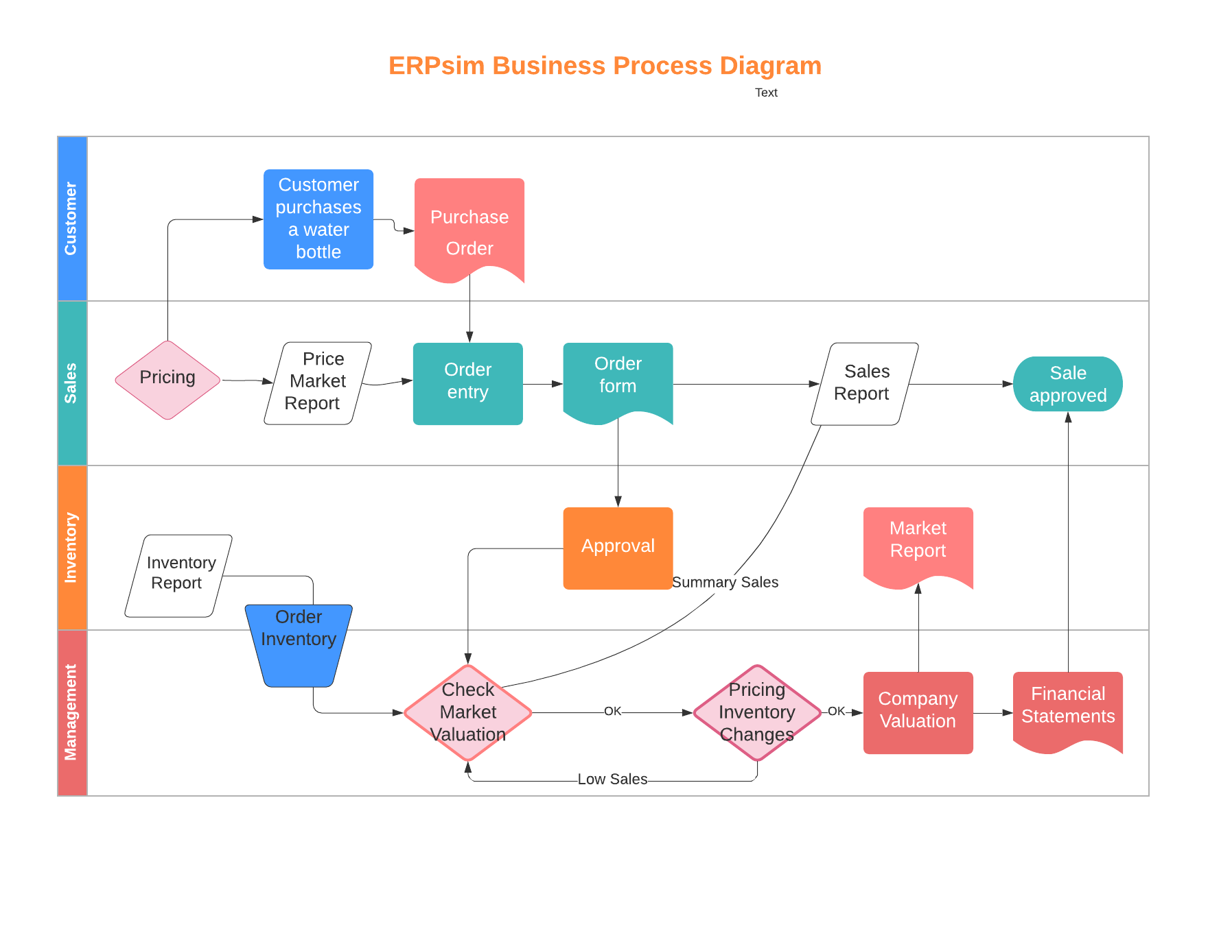

Company BB hinged on the business process to operate efficiently. The company focused on the resulting reports to influence our decision making. Our primary processes were Customer, Sales, Inventory, and Management. The customer initiates the bulk purchase which automatically produces a purchase order and is later translated into an order entry. Our pricing decisions were made using the price market report and order data. In ERPsim, sales were automatically approved and used to generate the sales and inventory reports. This prompted Company BB to order inventory and, as general practice, to check the market valuation, inventory, and pricing which altered our business strategy. The process is summated in the company valuation and financial statements.

# Evolving Business Strategy

While Company BB focused on remaining the low cost provider, our strategic planning evolved throughout the fiscal year (2 quarters) of the SAP ERP Simulation. Initially, our sales bounded as our prices were significantly lower than our competitors. Unfortunately, due to poor inventory management, our inventory dropped substantially resulting in a 33% rate of stock outs. After evaluating our strategy in relation to the market, Company BB decided to increase prices in regions that were performing well and to increase marketing cost for products that were not selling. Simultaneously, we adjusted our inventory to match demand. As the simulation came to a close, we realized that our strategy, although externally facing, failed to produce a higher profit margin. Our main competitor, Company AA, was more introspective in their market analysis causing them to make real time changes that Company BB failed to utilize. Our emphasis on the market resulted in our downfall.

# Sales Data Multidimensional Modeling

## **Figure 2 - Sales Data Star Schema**

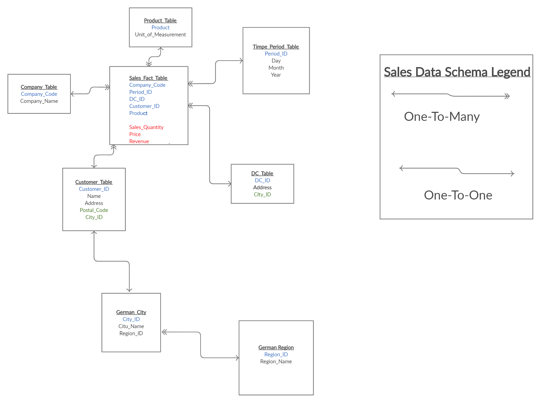

The sales data is organized into a snowflake schema, which is centered around the Sales Fact Table. The Sales Fact Table contains transactional data and the foreign keys that are linked to the dimension tables. It must be noted that the Customer Table connects to the German City table, which then connects to the German Region table. This is done to provide more granularity about data regarding the customer’s location.

# Purchase Order Multidimensional Modeling

## **Figure 3 - Purchase Order Star Schema**

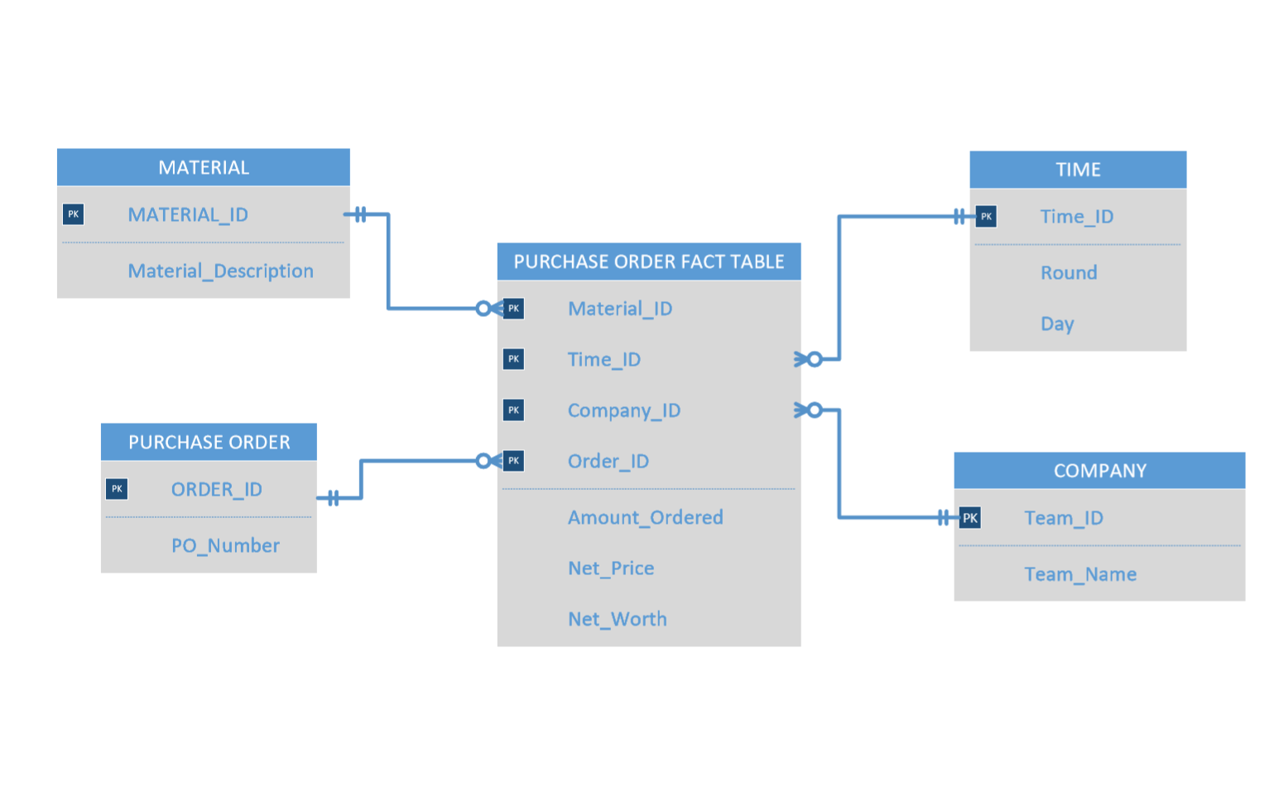

The purchase order schema depicts the relationship between time, company, purchase order, and material. The primary key is the Material_ID which is supported by the Order_ID and Company_ID. The purchase order details provides additional information as to when a purchase was made and it is used in conjunction with the inventory table.

# Marketing Multidimensional Modeling

## **Figure 4 - Marketing Star Schema**

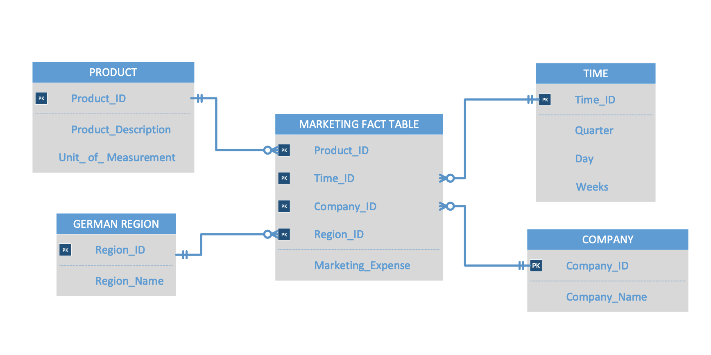

Marketing star schema depicts the relationship between company, product and time. The primary key for the fact table consists of a single composite key that is created from Region_ID, Product_ID, Company_ID and Time_ID. Market manager needs to know how much company BB is spending in marketing to promote specific products in the German market.

# 

# Sales Revenue

## **Figure 5 - Sales Revenue by Company AA, BB, CC in Fiscal Year(2 Quarters)**

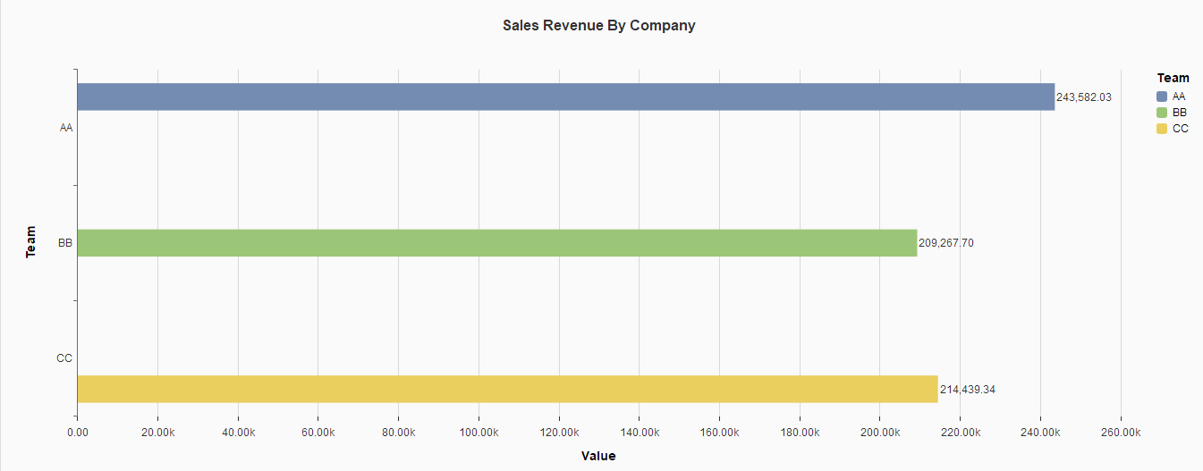

Company AA was able to generate the most sales revenue, which is €243,582.03. This finding is significant because having a high sales revenue is vital in obtaining the best company valuation.

## **Figure 6 - Sales Revenue by Product in Fiscal Year (2 Quarters)[2]**

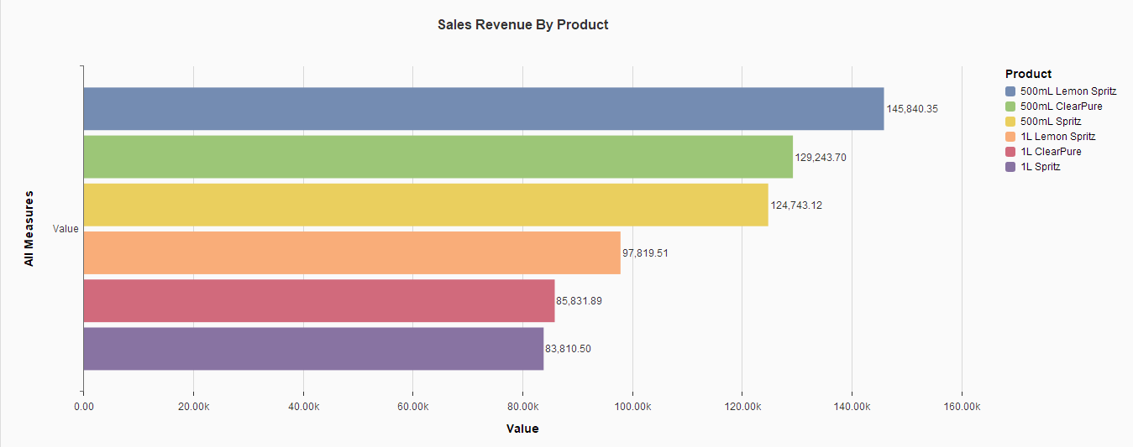The product that generated the most sales revenue was 500mL Lemon Spritz. The sales revenue from 500ml Lemon Spritz €145,840.35. This shows that 500mL Lemon Spritz was the lucrative product that is offered by the three companies.

## **Figure 7 - Sales Revenue Trends for Company AA, BB, CC in Fiscal Year (2 Quarters)**

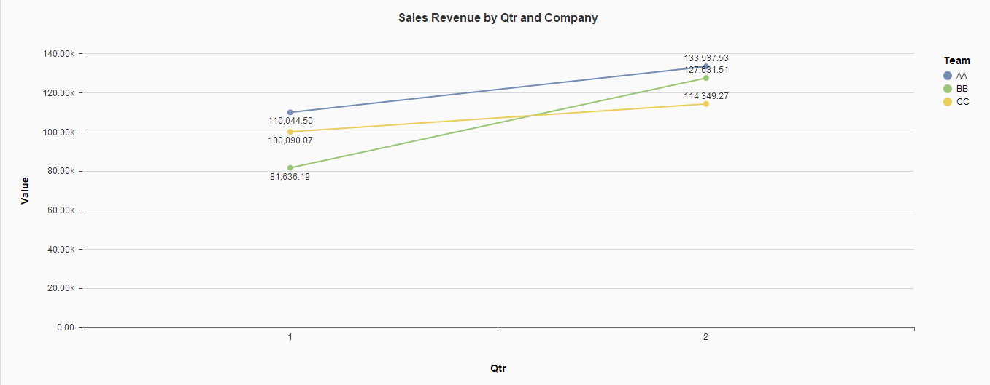

All three companies have experienced a positive trend in Sales revenue. For instance, Company BB earned €81,613.19 in quarter 01 and €127,631.51--which is about a 56.39% increase. This means our company had a better performance in quarter 02. However, Company AA generated the most sales revenue in both quarters. Overall, this means that all the companies were able to improve on their sale strategery.

# Market Analysis

## **Figure 8 - Market Share of Products by Company AA, BB, CC in Fiscal Year (2 Quarters)**

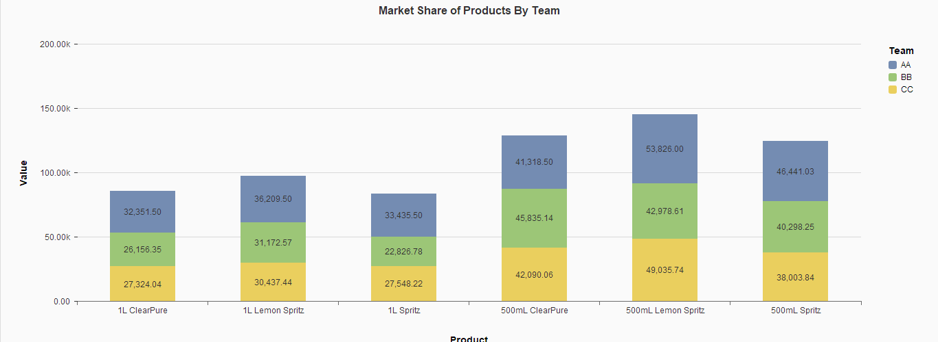

Company AA had the largest market share of most products with the notable exception of 500mL ClearPure. However, the market share of Company AA was not that larger than the shares of Company BB and Company CC. This shows that no single company dominated the market. This proves that we were operating in a highly competitive market without any dominant organization.

## **Figure 9 - Average Price of Product by Company AA, BB, CC in Fiscal Year (2 Quarters)**

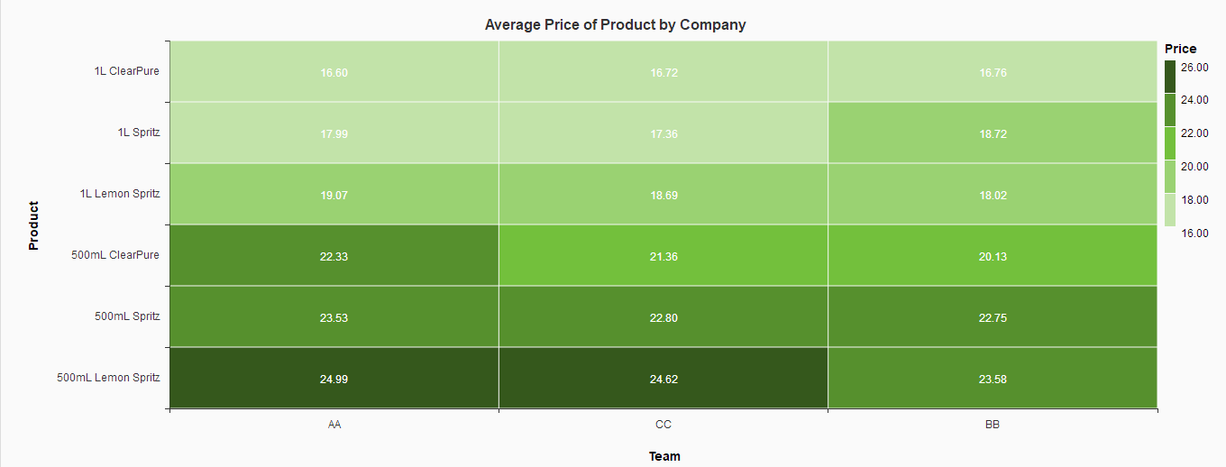

The two most significant findings are that Company AA had the highest average price and Company BB had the lowest average price. This means that Company AA generated the most sales revenue per sale and Company BB generated less revenue per sale.

## **Figure 10 - Highest Price of Product by Company AA, BB, CC in Fiscal Year (2 Quarters)**

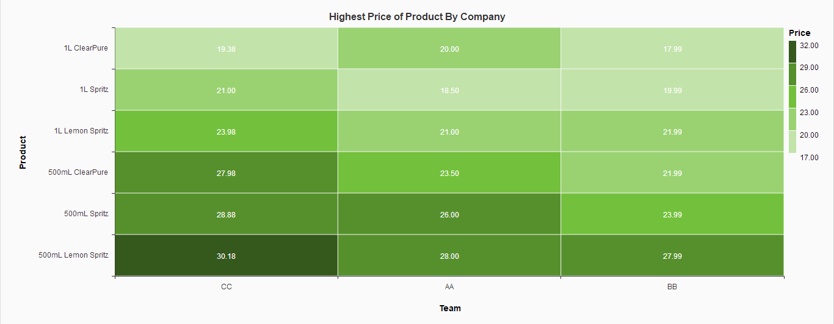

The most expensive product sold was 500mL Lemon Spritz and its highest price was €30.18 and was sold by Company CC. This heat map highlights the fact that Company BB set its prices lower than their two competitors. Overall, Company BB prices were too low to be competitive in this market.

## **Figure 11 - Total Units Sold by Product and Company AA, BB, CC, in Fiscal Year**

## **(2 Quarters)**

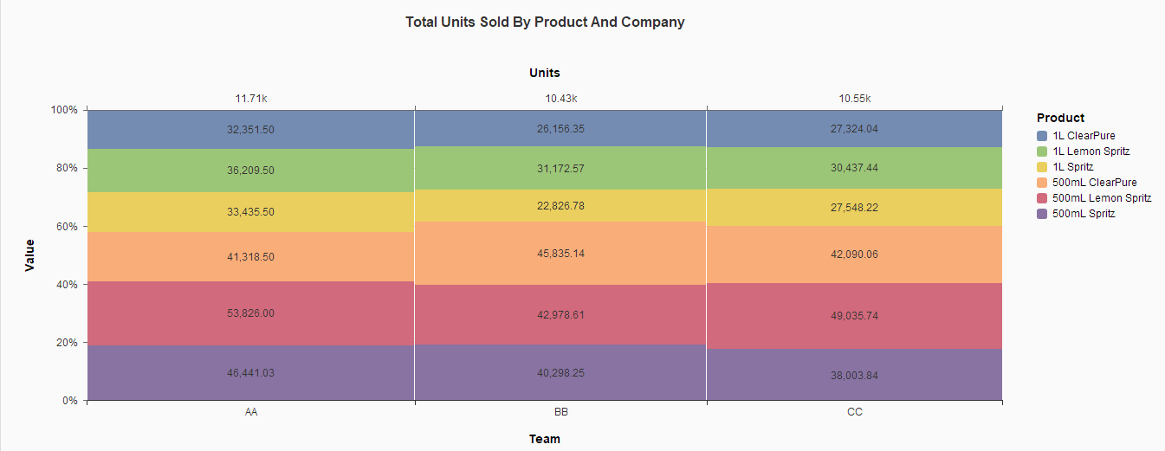

The Marimekko map shows that Company AA sold most of the product, and 500mL Lemon is the single product that is sold the most by Company AA. It must be noted that Company AA had a slight lead over Company BB and Company CC. This shows that the sales market is very competitive, but Company AA was still able to keep up with demands.

## **Figure 12 - Correlation of Sales Price to Revenue by Company AA, BB, CC in Fiscal Year (2 Quarters)**

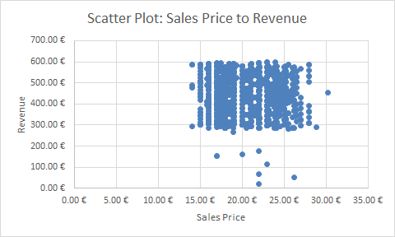  
*Correlation Coefficient: -0.03*

The scatter plot shows that price and value have a negative correlation. Moreover, the correlation coefficient is near 0 which means that these two variables do not influence each other. This means that the sales price will not translate to a higher sales revenue. Our sales strategy of low prices did not impact our company potential to generate higher sales revenue. Overall, this means that sales price was not a determining factor for the consumer.

## **Figure 13 - Sales Revenue by Quarter and Day For Company AA, BB, CC in Fiscal Year**

## **(2 Quarters)**

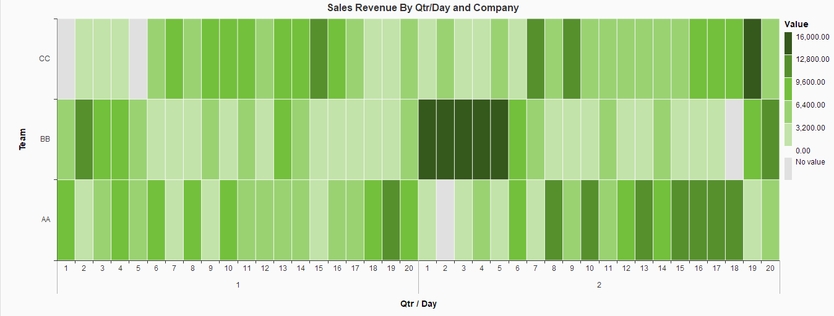

The single day that generated the most sales revenue was day 03 in quarter 02; on that day Company BB generated the most sales revenue of €15,806.78. However, the heat map shows that Company BB does not have a consistent stream of sales revenue. The heat map shows that Company AA and Company CC both have a stable source of sales revenue. Overall, our sales strategery is not stable and fluctuates heavily.

## **Figure 14 - Sales Revenue by Product for Company AA, BB, CC in Fiscal Year**

## **(2 Quarters)**

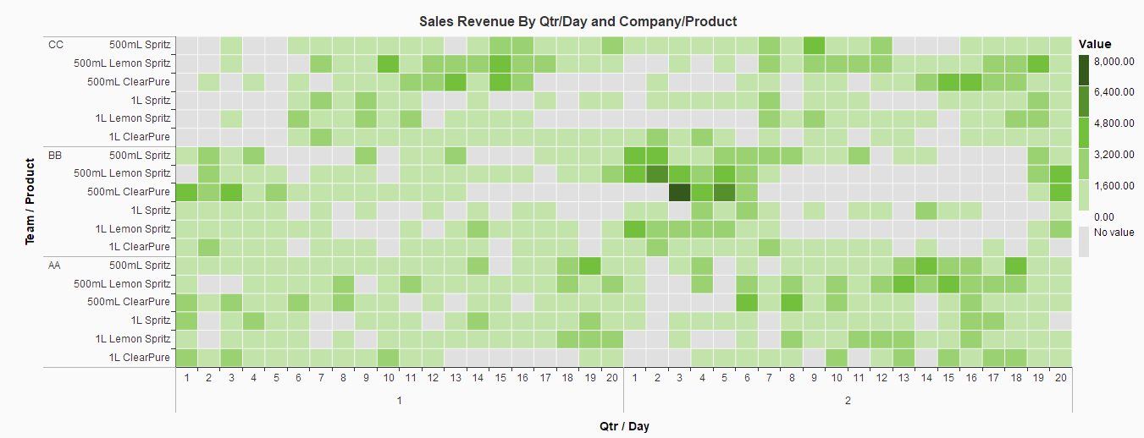

500 mL Clear Pure generated the most sales revenue on day 03 and quarter 02 (€7,44.08) for Company BB However, the heat map shows that Company BB has experienced many days that generated no sales revenue. Company AA had fewer days in which they experienced no sales revenue. This is further evidence that our sales strategy failed to produce a stable source of sales revenue.

# **Inventory Analysis**

## **Figure 15 - Inventory Level Master For Company AA, BB, CC in Fiscal Year (2 Quarters)**

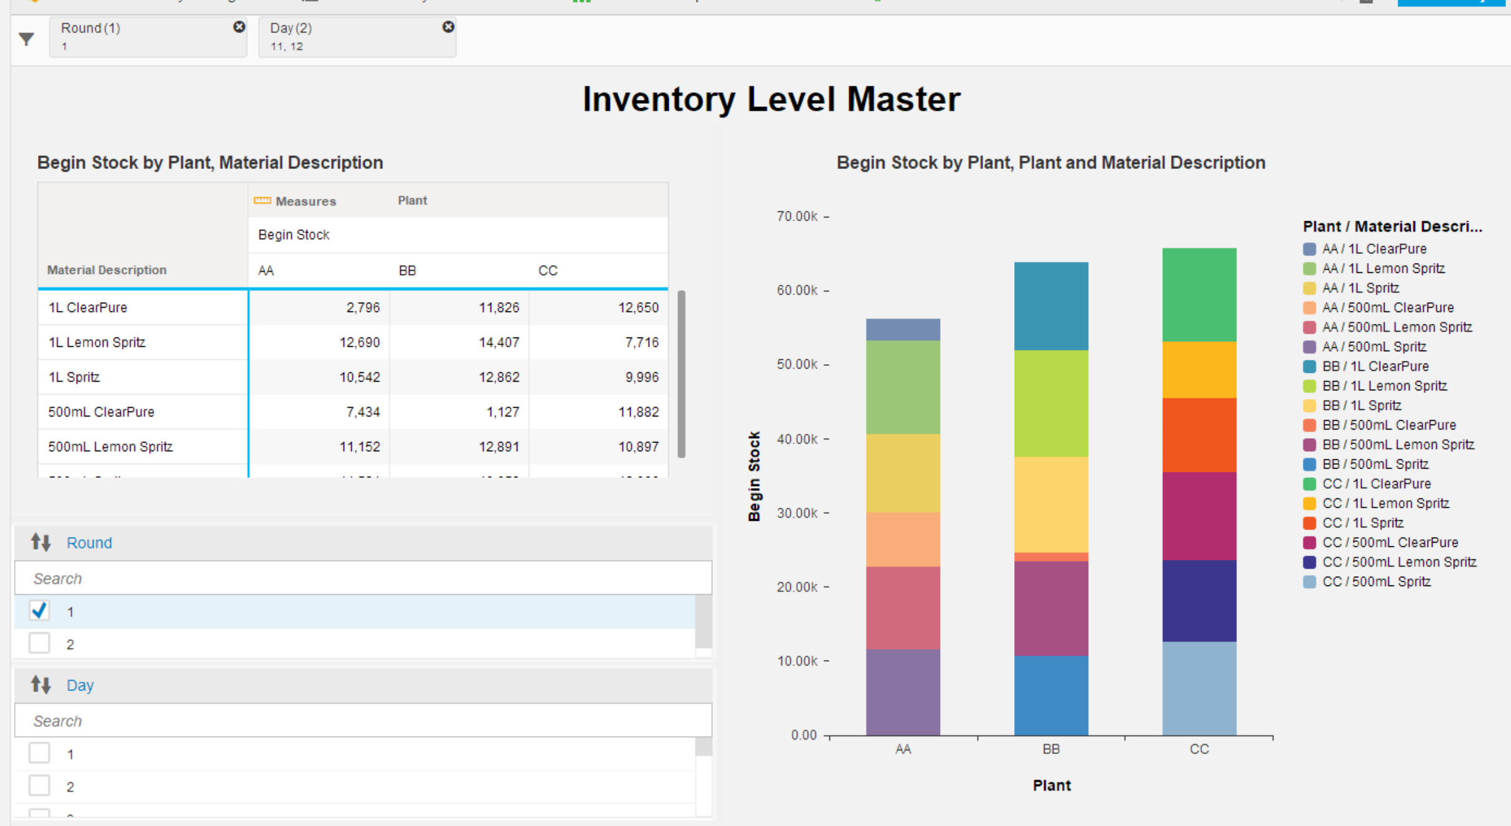

An interactive chart has been created above to display the daily inventory for each company based on a filter that can be applied per quarter and per day. The stacked bar on the right provides the individual stock levels per product. A closer look can be provided by another interactive chart shown below. With these interactive charts, we can ask many questions about stock levels and find the answer fairly easy. For example, as we can see from the snapshot, that the 500 ml Spritz was out of stock for 4 days in quarter 2 while the winning company never completely ran out of stock for that product. The rest of the other product stock outs can be found by filtering the product.

## **Figure 16.a - Product Daily Inventory For Company AA, BB in Fiscal year (2 Quarters)**

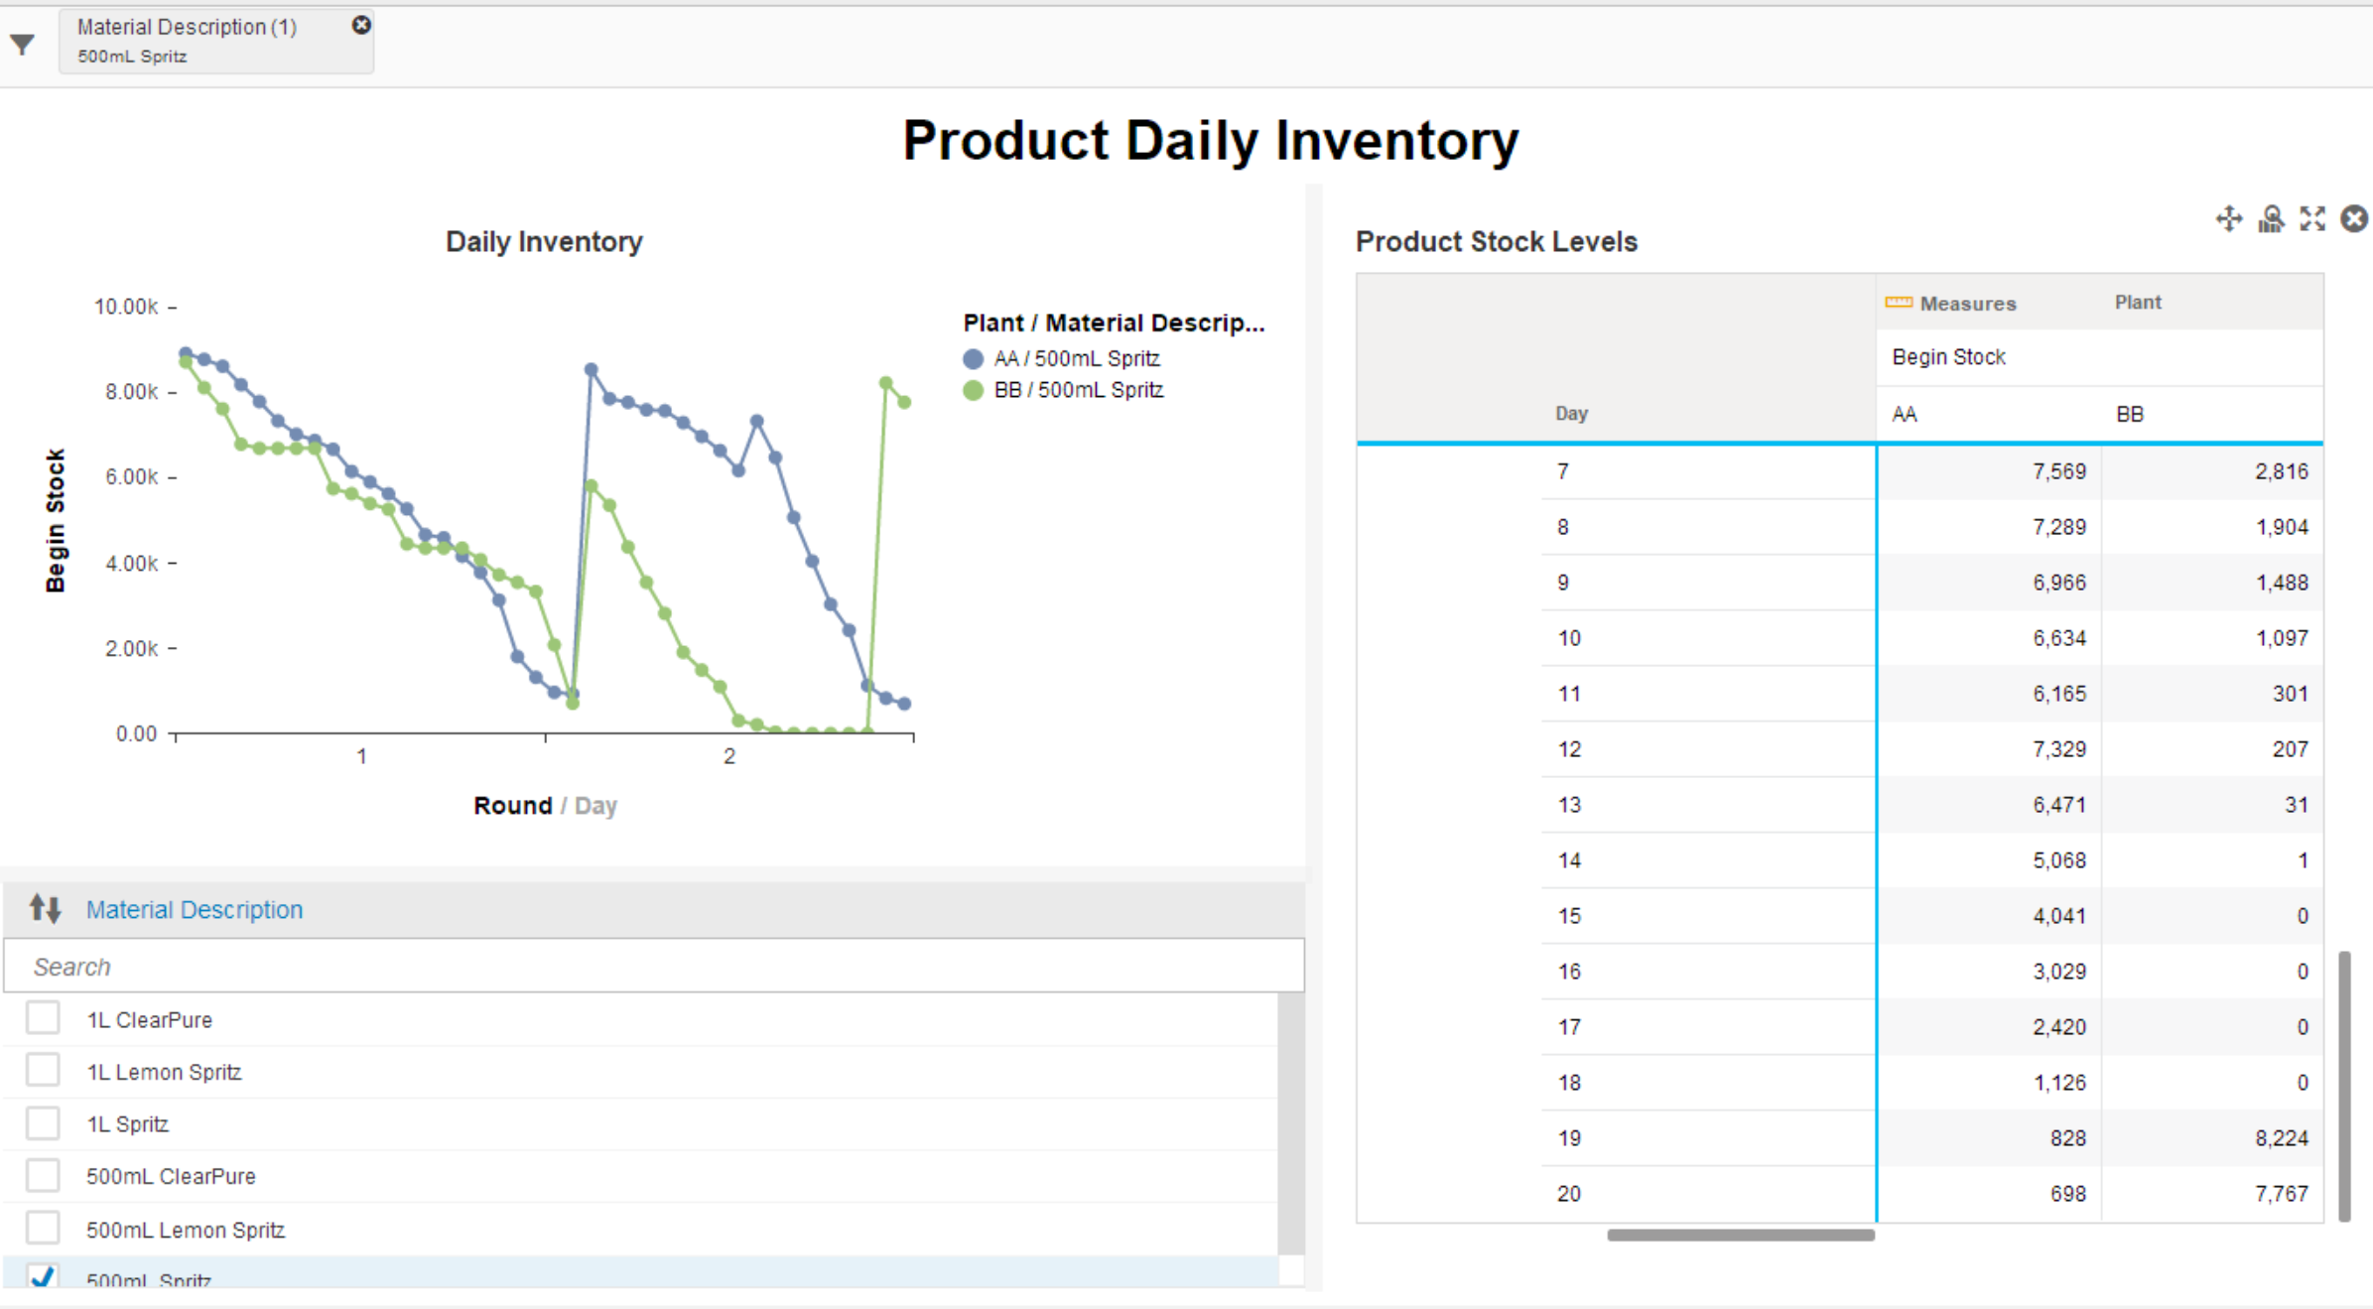

## **Figure 16.b - Daily Sales Quantity For Company AA, BB in Fiscal Year (2 Quarters)**

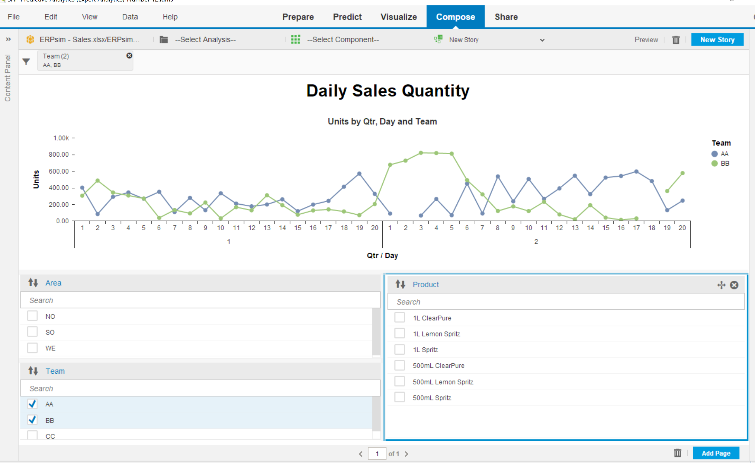

An interactive chart has been created above to allow for filtering of daily sales quantity by region, by product, and by company. For example, the screenshot above shows all sales quantities from all areas that company AA (winner company) and Company BB had for the entire quarter/days. By selecting a region to filter, a further analysis can be done to determine the sales quantity per region.

## **Figure 17 - Average Price Trends by Company AA, BB for Fiscal Year (2 Quarters)**

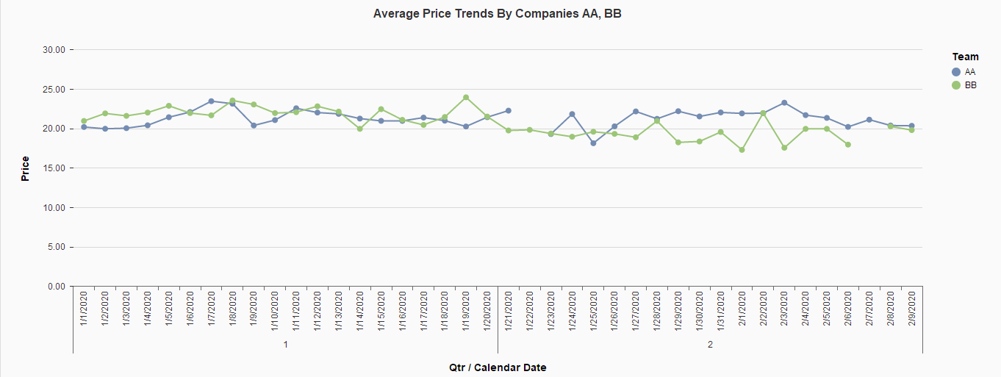

The price trend for Company AA is very stable, which means they increase/decrease their prices gradually. However, the price trend for Company BB is very volatile which was a result of increasing/decreasing to respond to our performance. However, our prices were not consistent and too responsive to the market.

## **Figure 18 - Sales Revenue Per Product By Region in Fiscal Year (2 Quarters)**

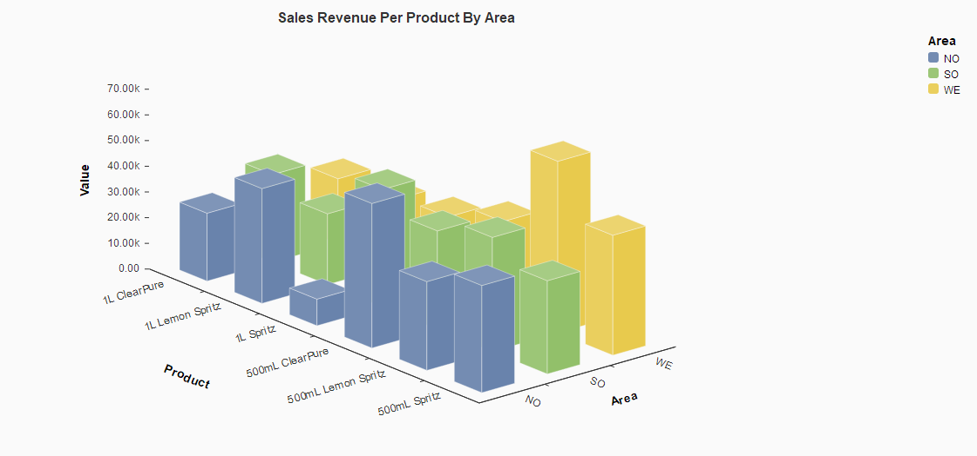

The German regions all have a unique market and buying behaviors. For instance, the North and South regions have a strong regional preference. The people from the northern region prefer 500mL ClearPure and people from the west really enjoy 500mL Lemon Spritz. The south region has a slight preference for 1L Spritz, but the people still buy other drinks at comparable rates. If Company BB matches the regional preference then it should translate to higher sales revenue.

# Conclusion

Company AA was valuated higher than the other companies in the market. The company was able to surpass its competitors by being a middle market player. While its competitor, Company BB, focused on increased profit margins by selling at a lower price, Company AA spent more on marketing and sold the most products at a price closer to cost. While Company BB had substantial overstock, based on its amount of finished goods, Company CC was close to a stock out. Company AA was competitive in having enough goods to address market needs.

In the next game, Company BB plans to adopt company AA’s inventory strategy. However, our pricing would increase by 5% for products that are most popular, depending on region. In the first game, Company AA failed to benefit from larger profit margins because it’s cost-centered pricing approach. Company BB will increase spending on marketing for less profitable regions and increase the price for popular products in higher performing regions.

In order to improve our sales strategy, Company BB will stabilize the price of our products. We came to this decision because our prices were too volatile. In future, we will set prices low then gradually increase price to keep preserver inventory. This will ensure that our company will have a consistent source of sales revenue if we had to play the ERPSIM again.

1. Company Valuation= (Current Profit/Number of Rounds) *12= (522,598/2)*12(7+3) = (261,299)*(120) = €31,355,880
2. Figure 6 includes sales revenue from company AA, BB, CC